Create Node-RED Service

|  |  |
| --- | --- |
| Team ID | PNT2022TMID016894 |
| Project Name | Real-Time River Water Quality Monitoring and Control System |

Step1:

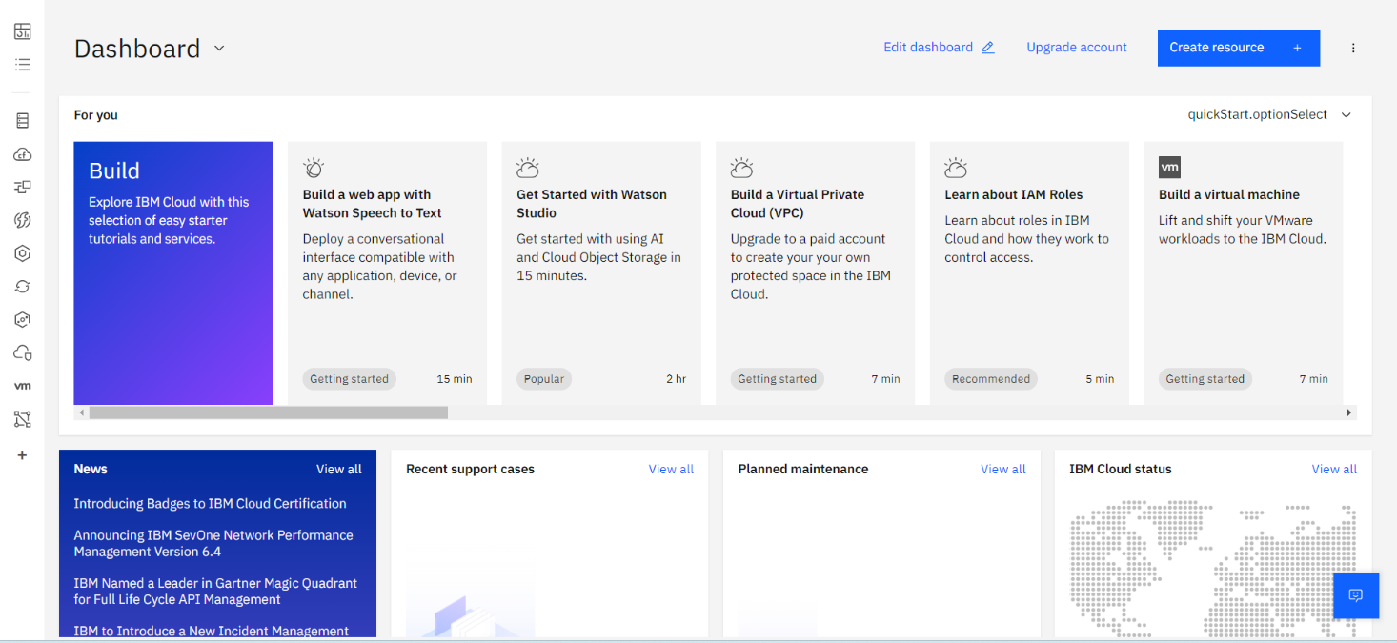

Step 2:

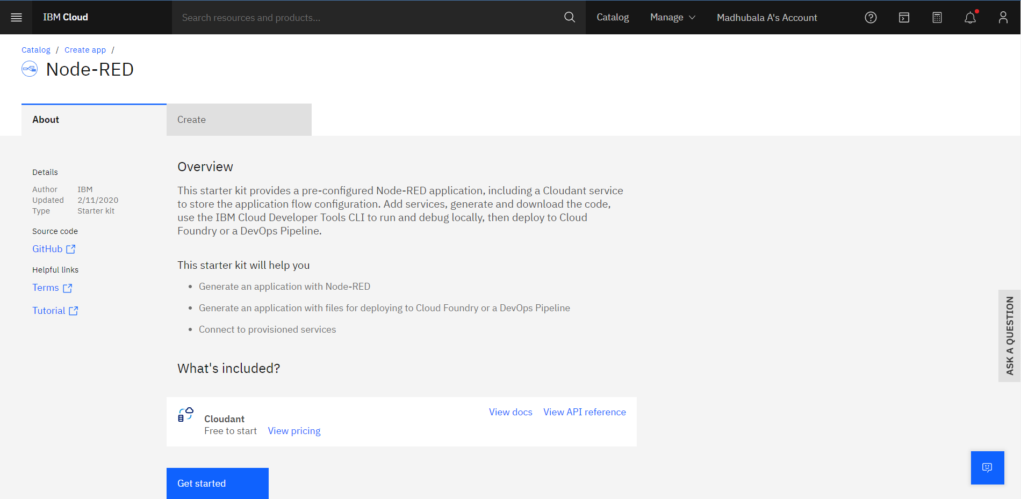

Step3:

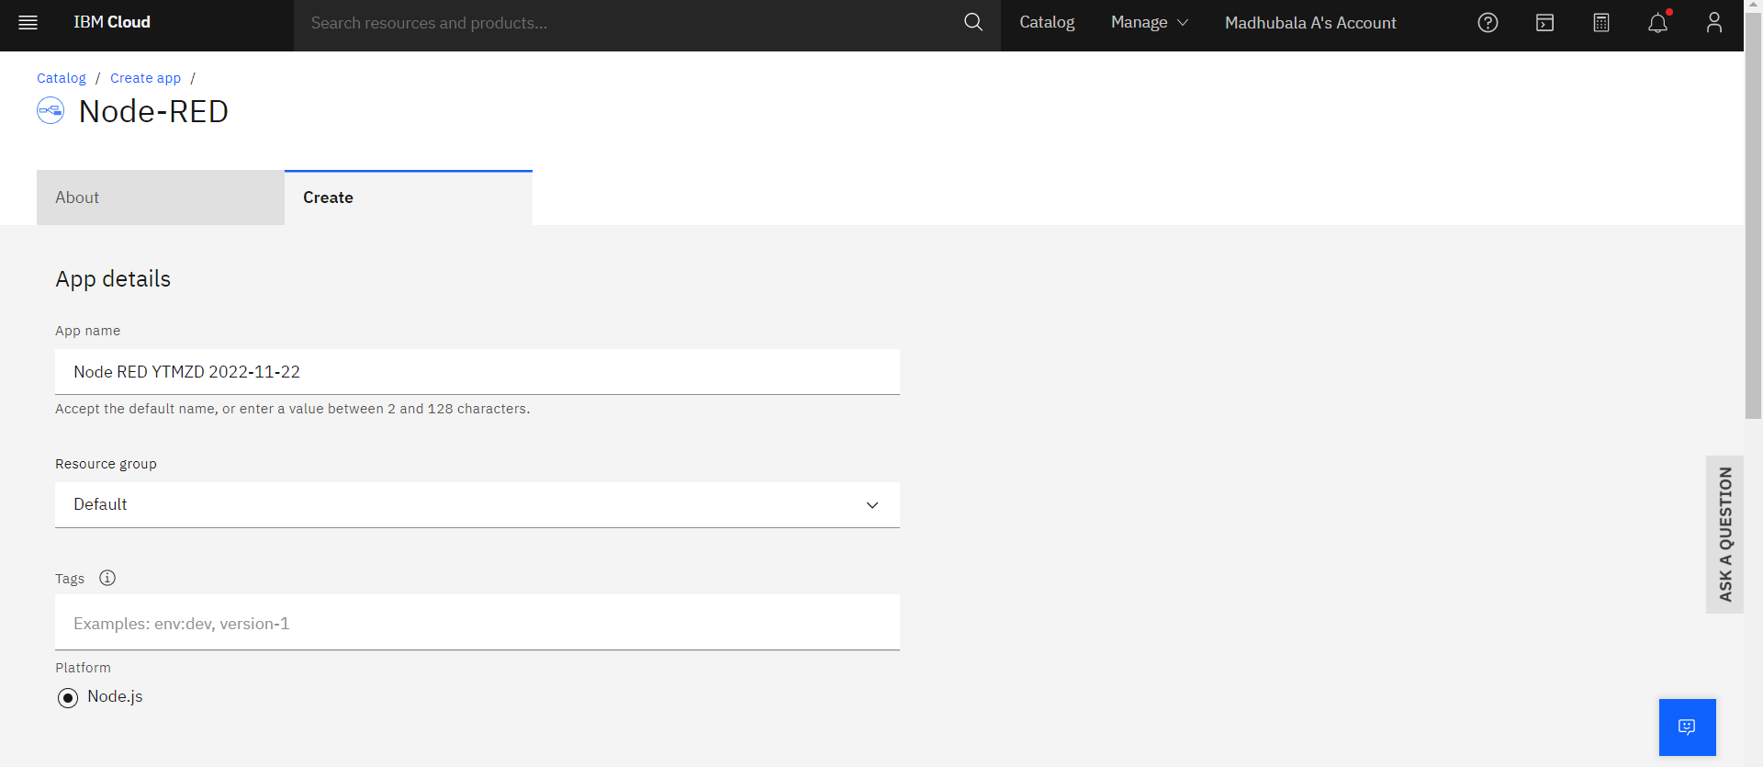

Step4:

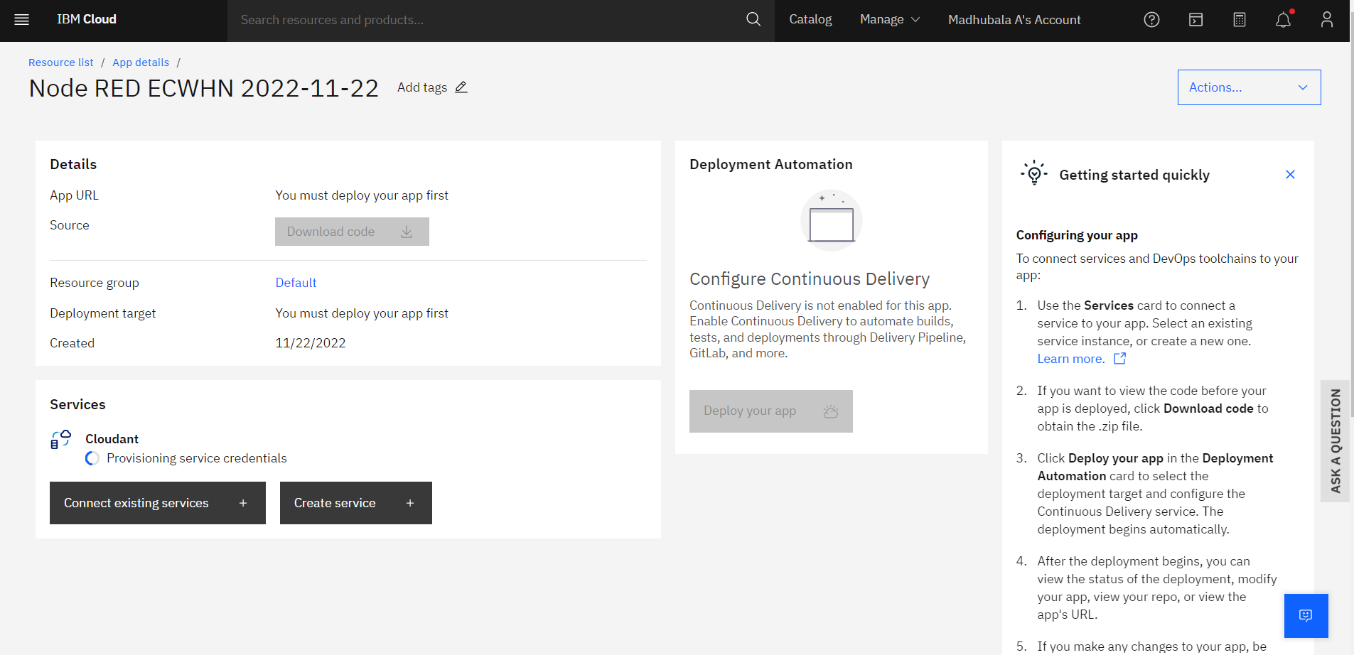

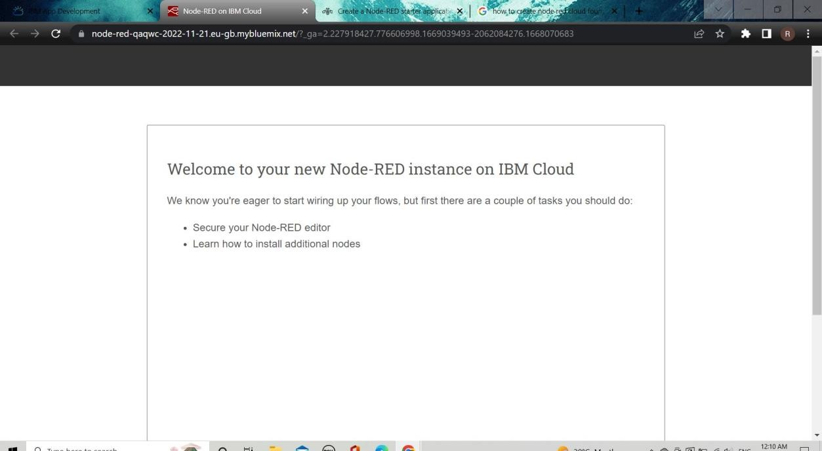

Step6:

Step7:

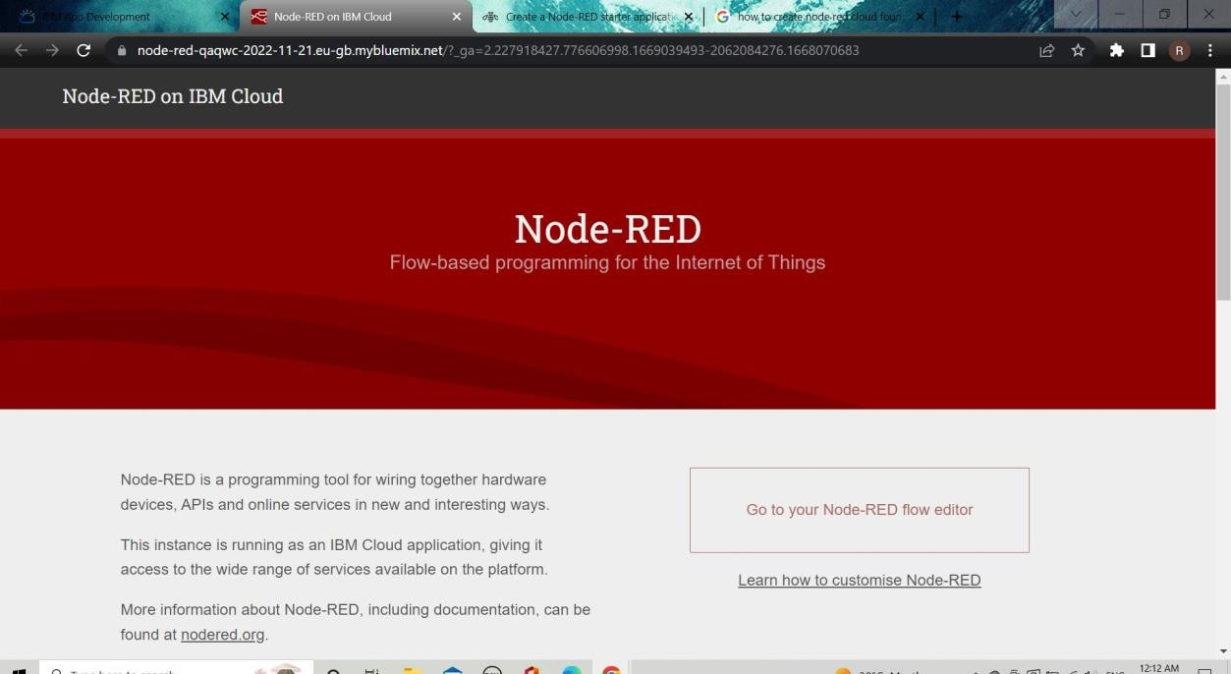

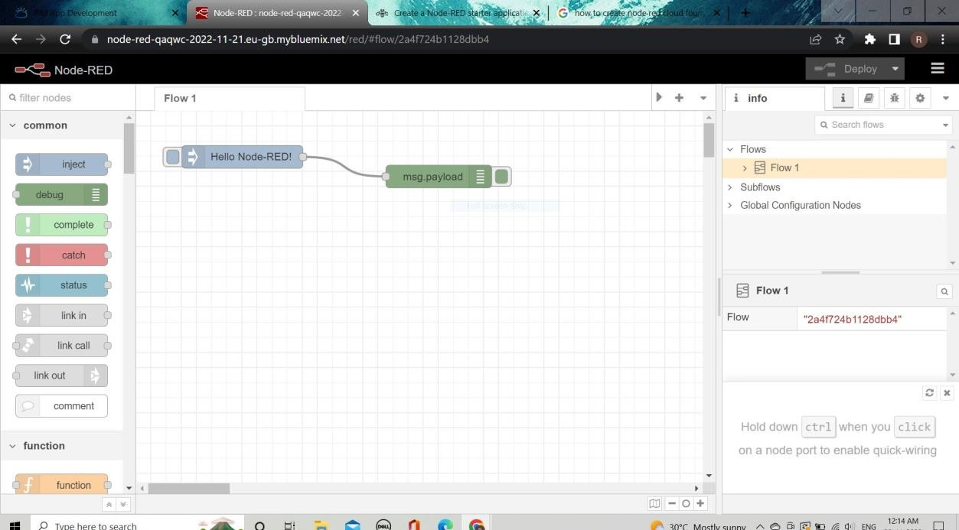step8: